NAME:Rwakibibi Gihozo Zubeir
ID: 24181
WEB-TECH FINAL PROJECT
Project Title: Online Banking System

Introduction:
Online banking has become an indispensable part of modern society, offering a range of benefits and solutions to prevalent issues. This project aims to enhance the efficiency of banking services by providing a user-friendly online platform. The key functional requirements, features, system architecture, technology stack, and deployment details contribute to a comprehensive and robust online banking experience.

Benefits and Problem Solving:
1. Convenience and Accessibility: Online banking facilitates anytime, anywhere access to financial services, reducing the need for physical visits to banks.

2. Transaction Efficiency: The system streamlines transaction processing, enabling swift and secure fund transfers, bill payments, and account management.

3. Data Security: Robust security measures safeguard customer data, ensuring privacy and protection against unauthorized access.

4. Reporting and Analytics: The system provides valuable insights through reporting and analytics, empowering better decision-making for both customers and the bank.

Expected Outcomes:
1. Enhanced Customer Experience: Users will benefit from a seamless, intuitive interface, leading to increased satisfaction and loyalty.

2. Operational Efficiency: The automation of routine banking tasks will result in improved operational efficiency and reduced manual errors.

3. Increased Financial Inclusion: Online banking opens up financial services to a broader audience, fostering greater financial inclusion.

Key Functional Requirements and Beliefs:
1. User Registration and Profiles: Efficient registration and profile management are fundamental. A seamless on boarding process ensures user satisfaction and engagement.

2. Search and Filtering: Intuitive search and filtering options enhance user experience, allowing customers to quickly locate specific transactions or information.

3. Dashboard: A well-designed dashboard provides a snapshot of account activity, promoting transparency and ease of use.

4. Login Page: The login page is the gateway to the system, and its security features are paramount to protect user credentials.

5. Pagination: Effective pagination ensures that users can navigate through data efficiently, particularly in scenarios with a large number of transactions.

6. Error Handling: A robust error-handling mechanism enhances user experience by providing clear and informative messages, aiding issue resolution.

7. File Upload and Download: This feature streamlines processes like uploading documents for account verification or downloading account statements.

8. Validation: Implementing error messages for incorrect credentials strengthens security and guides users toward the correct login information.

Technology Stack:
The Bank Management System leverages a technology stack tailored to its specific requirements:

Programming Language: Java.
Web Development: HTML, CSS, Bootstrap.
Database: The system relies on a robust relational database, such as Postgres, for efficient data storage, retrieval, and management.
Security: Encryption algorithms, secure protocols (HTTPS), and authentication mechanisms ensure the integrity and confidentiality of sensitive information.

Database Schema:
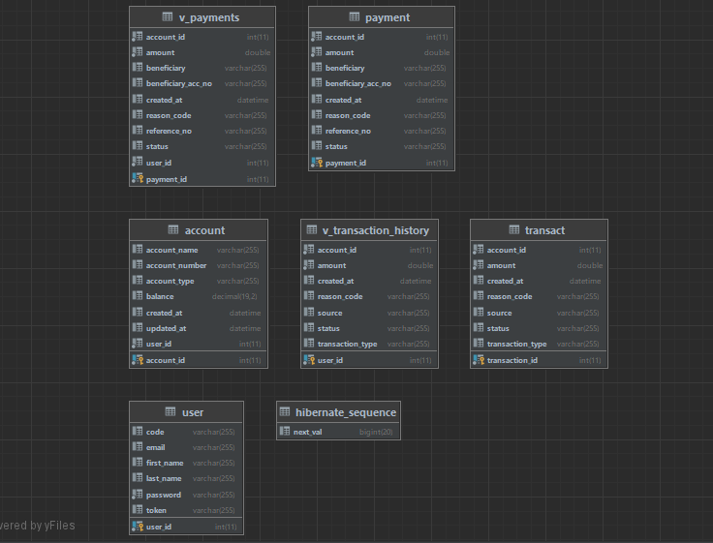

Conclusion:

The Online Banking System represents a pivotal advancement in modern finance, seamlessly blending convenience, security, and efficiency. By addressing the key facets of user experience, operational efficacy, and financial inclusion, the project stands as a beacon of innovation. With a meticulously crafted technology stack, robust security measures, and a commitment to user-centric design, this system not only meets but surpasses the evolving expectations of a dynamic society. As it unfolds into the digital landscape, the Online Banking System promises not just a service but a transformative experience that redefines the way we interact with financial services.

